[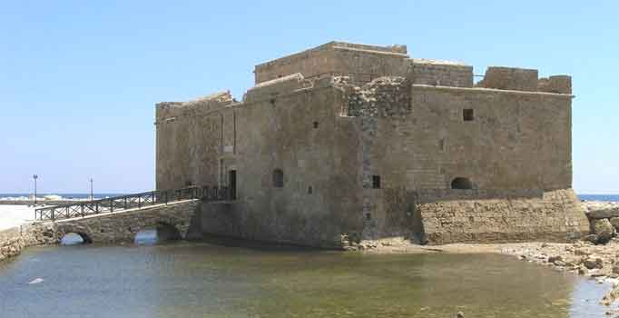](http://www.google.com.cy/url?sa=i&rct=j&q=&esrc=s&frm=1&source=images&cd=&cad=rja&docid=34CZLmQJ-i7ZiM&tbnid=Kdw0KgKGGPIGgM:&ved=0CAUQjRw&url=http://www.hellenica.de/Griechenland/Zypern/GR/Pafos.html&ei=-TVRUr-NM4mGswawiICQDg&bvm=bv.53537100,d.Yms&psig=AFQjCNEtj6KSbYUN1OGOqZ8Y37g273GPQQ&ust=1381140314066386)[](http://www.google.com.cy/url?sa=i&rct=j&q=&esrc=s&frm=1&source=images&cd=&cad=rja&docid=ZfaHMi2pGwPVbM&tbnid=i2mf3SkDNMgIfM:&ved=0CAUQjRw&url=http://www.kathimerini.com.cy/index.php?pageaction=kat&modid=1&artid=117999&show=Y&ei=QfBKUryuGLTw0gWNkIGwBQ&bvm=bv.53371865,d.bGE&psig=AFQjCNETvdWm2OUuBBvp26LV246KzIxeog&ust=1380729273798556)

Το Κάστρο

[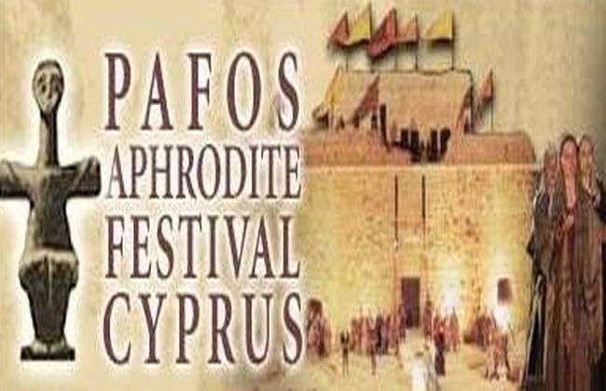](http://www.google.com.cy/url?sa=i&rct=j&q=&esrc=s&frm=1&source=images&cd=&cad=rja&docid=lIqO5o82B2qTMM&tbnid=Ni4Dpmv5v4vg-M:&ved=0CAUQjRw&url=http://www.livenews.com.cy/cgibin/hweb?-A=24465&-V=politismos&ei=E0pRUujBLsTDtQaJzIDoAg&bvm=bv.53537100,d.Yms&psig=AFQjCNGRXBsv9Tdw39kLhvZX1AnPlJQ2Mg&ust=1381145476670942)[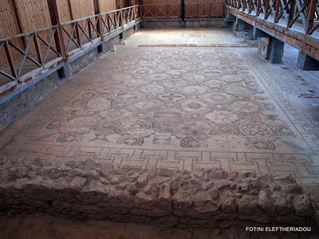](http://www.google.com.cy/url?sa=i&rct=j&q=&esrc=s&frm=1&source=images&cd=&cad=rja&docid=uesTUlFup2ddsM&tbnid=9sDn0b3dRfXoOM:&ved=0CAUQjRw&url=http://taxidiaris.blogspot.com/2011/12/mosaics-of-pafos-cyprus.html&ei=rUBRUuiGBqnB0gW7kYCwBg&bvm=bv.53537100,d.bGE&psig=AFQjCNFQW50vVYywH_865GLKqnWhXYwtOg&ust=1381143049553642)

Τάφοι των Βασιλέων

Ταφοι τ[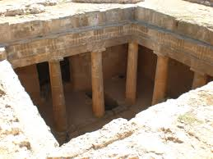](http://www.google.com.cy/url?sa=i&rct=j&q=&esrc=s&frm=1&source=images&cd=&cad=rja&docid=DgmTxb9m93jU0M&tbnid=DmMhe-iG_tk4RM:&ved=0CAUQjRw&url=http://www.panoramio.com/photo/87196103&ei=XDhRUsW3LIaJtQbnlIHACA&bvm=bv.53537100,d.Yms&psig=AFQjCNFNvYGaSbUgeE8wcseOUGylmjaAFQ&ust=1381140854075944)

Ψηφιδωτά

Όπερα στη Πάφο

[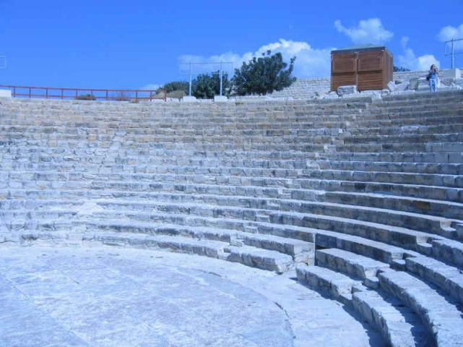](http://www.google.com.cy/url?sa=i&rct=j&q=&esrc=s&frm=1&source=images&cd=&cad=rja&docid=hpk2ap6UjQGiZM&tbnid=bPUW8L2c41ElyM:&ved=0CAUQjRw&url=http://www.sigmalive.com/news/politics/504193&ei=yjZRUofxFcextAaF1oGIBg&bvm=bv.53537100,d.Yms&psig=AFQjCNHbHA1iW7cm-OKcVcSpjaRZo-PPqg&ust=1381140501673305)

Η πόλη της Αφροδίτης

[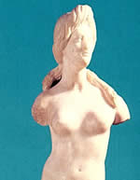](http://www.google.com.cy/url?sa=i&rct=j&q=&esrc=s&frm=1&source=images&cd=&cad=rja&docid=8y_iBqmsyypyrM&tbnid=RPKDaWXbK1WIFM:&ved=0CAUQjRw&url=http://www.kn-megalexandros.gr/68_Kipros.html&ei=RUFRUvmVH4aYtAaI9ICQCQ&psig=AFQjCNF23H-8qNvkpWQvhxr18m6Pe2c8SQ&ust=1381143199794107)[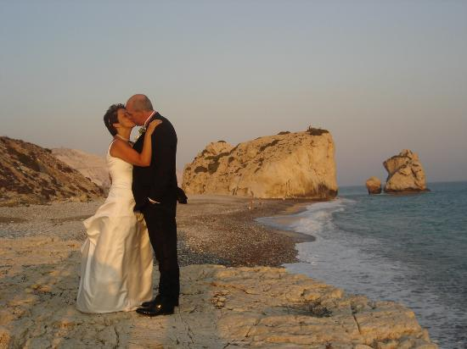](http://www.google.com.cy/url?sa=i&rct=j&q=&esrc=s&frm=1&source=images&cd=&cad=rja&docid=d9oaVOal_zp1EM&tbnid=aUx18hWIW09TeM:&ved=0CAUQjRw&url=http://www.tripadvisor.ca/LocationPhotos-g190372-d313656-Petra_tou_Romiou-Cyprus.html&ei=YDdRUqSPJYjSsgazvIHoDQ&bvm=bv.53537100,d.Yms&psig=AFQjCNHxIdMS7N2k054VMxrqCKmzTPZgag&ust=1381140655177381)

Το Ωδείο

Φυσικό περιβάλλον

[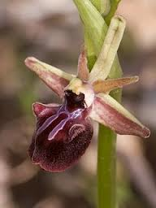](http://www.google.com.cy/url?sa=i&rct=j&q=&esrc=s&frm=1&source=images&cd=&cad=rja&docid=tPrJUo-hMZvCkM&tbnid=Kmq9qahTFdYrRM:&ved=0CAUQjRw&url=http://cyprus-orchids.blogspot.com/2010_03_01_archive.html&ei=NWVRUrLIHs7VsgbLiIHYBw&bvm=bv.53537100,d.Yms&psig=AFQjCNGu6ydGf43QfGSIoJ_KBPHwrqhivA&ust=1381152383582846)

[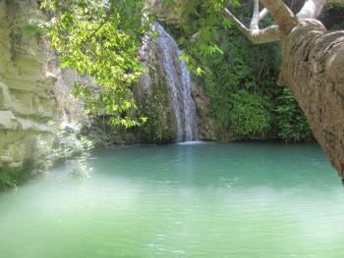](http://www.google.com.cy/url?sa=i&rct=j&q=&esrc=s&frm=1&source=images&cd=&cad=rja&docid=bpAF-W3q22vc6M&tbnid=F7M2Djm8WE5BTM:&ved=0CAUQjRw&url=http://www.cyladies.com/article/taxidiotikes-apodraseista-loytra-toy-adoni&ei=6zhRUpnWIoHXswaO0IHQAg&bvm=bv.53537100,d.Yms&psig=AFQjCNGL90Sxh0Kv9nCCRHCdxbXy2CxBVw&ust=1381141073065296)

Λαϊκή παράδοση

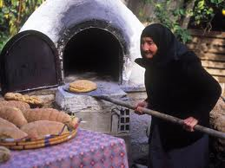

[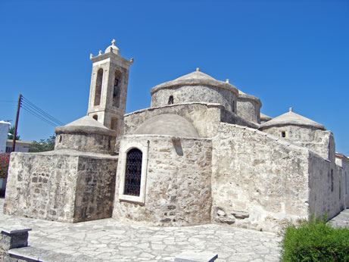](http://www.google.com.cy/url?sa=i&rct=j&q=&esrc=s&frm=1&source=images&cd=&cad=rja&docid=FA-49WDnwEINXM&tbnid=L8oSCICFIiuebM:&ved=0CAUQjRw&url=http://www.cyprushighlights.com/index.php/2011/07/23/%CE%B5%CE%BA%CE%BA%CE%BB%CE%B7%CF%83%CE%AF%CE%B1-%CE%B1%CE%B3%CE%AF%CE%B1%CF%82-%CF%80%CE%B1%CF%81%CE%B1%CF%83%CE%BA%CE%B5%CF%85%CE%AE%CF%82-%CF%83%CF%84%CE%B7%CE%BD-%CE%B3%CE%B5%CF%81%CE%BF%CF%83/&ei=4D9RUpHzFqqY0QX_4YCABQ&bvm=bv.53537100,d.bGE&psig=AFQjCNETv7I4XDZdjmDMsfRZBAPtTdPjLA&ust=1381142868014764)[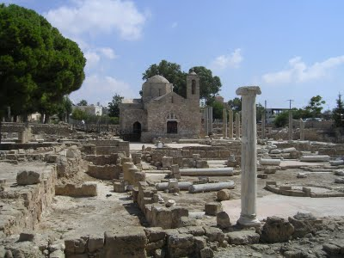](http://www.google.com.cy/url?sa=i&rct=j&q=&esrc=s&frm=1&source=images&cd=&cad=rja&docid=NvL0DWoHtIsdcM&tbnid=SYcnGmdBpR2twM:&ved=0CAUQjRw&url=http://www.churchofcyprus.org.cy/article.php?articleID=1245&ei=oD5RUq2fH4PV0QX4qYDYDA&bvm=bv.53537100,d.bGE&psig=AFQjCNHDjsmxko_wuqnewmjCQwVz-GMIkA&ust=1381142462408212)

**Αφίσα από τους μαθητές της Ε΄-Στ΄ τάξης στο μάθημα της Πληροφορικής.**

**Σχ. χρονιά 2016-17**

Μοναστήρια και εκκλησίες